Using the vBulletin Manual System
vBulletin.com has its own built-in manual system. The system is a little archaic and requires the use of BBCode. It doesn’t use HTML or XML style markups.

Accessing the Manual System
To access the manual system, you need access to to the vBulletin.com Admin Center with the appropriate permissions. The URL is:
https://admin.vbulletin.com/layout/manual.php

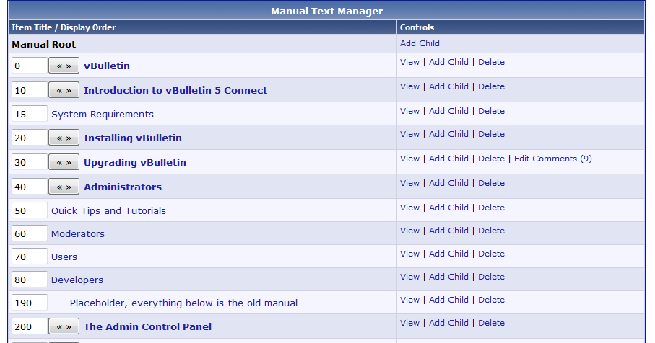
Above is a look at the layout of the Manual Manager Screen. The screen shows a hierarchical view of all manual entries. The screen allows you to manipulate display order, edit entries and see if any comments are applied to an entry. From Left to Right:
- On the left is the Display Order
- Expansion Button [« »]. If the entry has children, the expansion button appears.
- Entry Name. If the entry has children, the name will appear in bold.
- Controls - View, Add Child, Delete.

Previewing completed Manual entries
To view the entire manual within preview mode, use this link:
https://admin.vbulletin.com/layout/manual.php?do=previewmode

After using the above link, you can filter the manual to the vBulletin only entries with this link:
https://www.vbulletin.com/docs/html?manualversion=500000500

Creating a new Entry
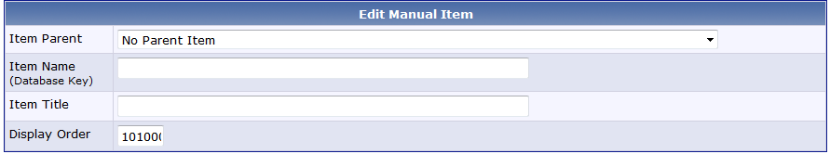

To start with a new entry, find the parent category in the list and click “Add Child” to the right.
Each entry requires three things to get started:
- Parent - Each entry should be a child of its category. This will be automatically selected.
- Item Name - This is a unique database key. It can consist of lowercase letters, numbers and the underscore ( _ ). prefixing this with vb5_ will most often make it unique. This Key becomes the URL keywords as well.
Please use the following prefixes in the Item Name:
  - sitebuilder_ - Site Builder Related
  - acp_ - All Pages in the Admin Control Panel
  - mod_ - All Pages in the Moderator Section
  - user_ - All Pages in the User Section.
Admin Control panel item names should be acp_section_path. So User Registration Options would be acp_settings_options_userregistration.
- Item Title - Non-unique name shown to the end user.

Note: To add a child to a specific heading, click the “Add Child” link or set the parent appropriately when editing. All entries must be a child of the architecture.

Display Order
When entering your new entry, the Display Order determines where it shows up in the display hierarchy. The first child should be entered as display order equals 10. Each subsequent child will automatically be ordered in increments of 10. This allows us to adjust or add new articles in later while reducing the amount of work needed in adjusting display orders.

Versioning
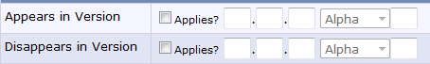

The manual allows for versioning of entries or articles. You can assign an entry to a specific version or allow it to be viewed across a range of versions. This is divided up into two entries. Appears In and Disappears In. In order to restrict the entry to vBulletin 5, you need to check the box for Appears In and then set the version boxes to 5 0 0 in sequence.

Controls
These are the different controls that allow you to select and apply BBCode to a string of text. The system is not a Rich Text Editor or WYSIWYG. Each button simply inserts the code around your selected text.

For a basic overview, the controls are:
B - Bold
I - Italic
U - Underline
Colors: Red, Yellow, Green, Blue, Black
Font Size: - (minus) smaller fonts, + (plus) larger fonts
Inline: A variety formatting options similar to using <span> in HTML.
Block: Block level formatting options. These are used to add Notes, Warnings or insert images and figures.
Links: Adding links within the Manual using [hop] and outside the manual using [url]
Multi: List control. We have the standard bullet list available as well as an ordered list called “Step” where the numbers are more pronounced and you can use to list a series of steps.

A complete listing of each BBCode including examples and output are included at the end of this document.

Active

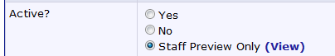

Determines the state of viewing for the customers. Pretty straight forwards here. Yes, means the customer can view the entry if they are viewing an appropriate manual version. No, means they cannot. Staff Preview Only only shows the entry in a Preview Mode, which is activated with the link above or by clicking ( View ).

Saving Entries
Entries are not automatically saved. You must submit the form to save entries. There are two options.

Again these are fairly straight forward. Clicking Save Item submits the form and returns you to the Manual Entry List. Click Save & Reload submits the form and then reloads it with the same content. This is a useful option if you’re working on a long entry and wish to preview your work or need to take a break.

Manual BBCode Definitions
These are outlined in the manual within preview mode. The page shows how each tag renders and its syntax.
See: https://www.vbulletin.com/docs/html/manual_bbcode

